Start Customer View

Connected JS to the Databas and required the directories I am going to need.

The start functions runs once the connection to the database is made. This will then prompt the items and their values in the console.

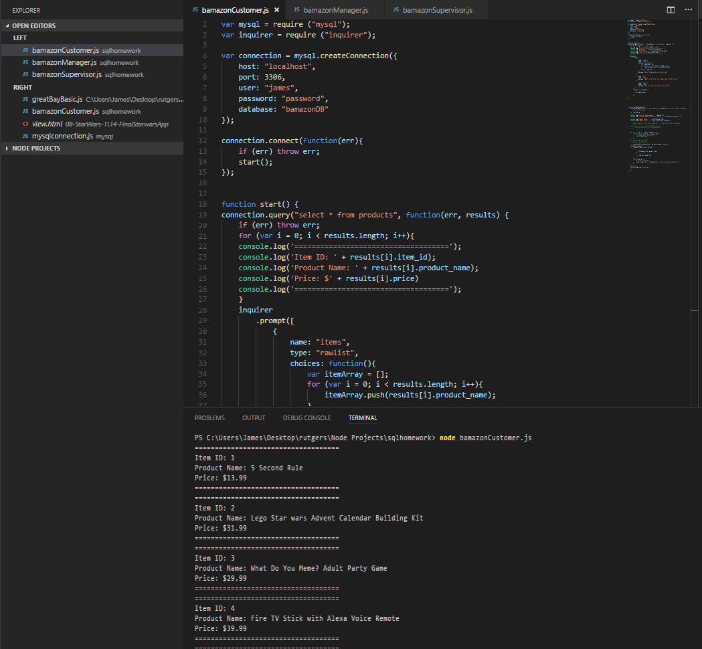

Created a database to hold products and values.

Below is an image of the database. The table is called products which has five columns.

Beneath that i’ve inserted a list of products.

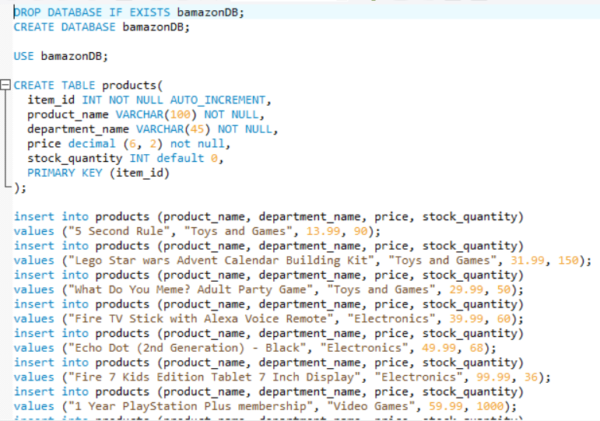

When selecting stock_quanitity I receive an error because it is not parsed as an integer.

